Student Name: Calvin Moylan

Student ID: 30018702

Date: 9/10/2020

Assessment Title: Portfolio One

## AT 2: Activity 6

## Design Specifications

For this application I am required to create a GUI program that can display CSV data with the help of a third party library. I chose to use “OpenCSV” for the third party library.

## Design Specifications Analysis

I have followed all necessary requirements for this task which were to create a GUI that would open a CSV file and then display that information in a table that relates to the header of the CSV file and the values at each column. A GUI has been created and the application loads from a CSV.

## Debugging

Loading CSV file:  
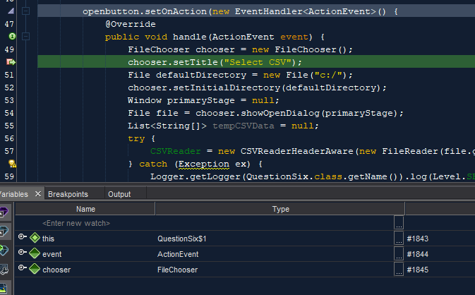  
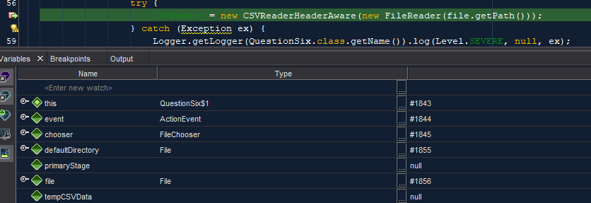  
Displaying CSV file:  
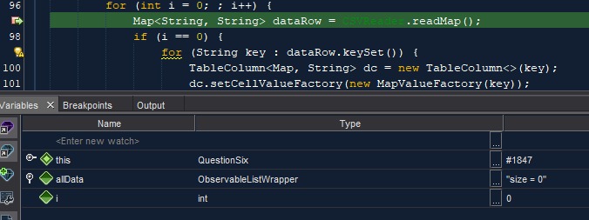

## Testing the Application

### Test and validate with sample inputs with screenshots.

|  |  |  |  |  |
| --- | --- | --- | --- | --- |
| **#** | **Test Case** | **Data** | **Expected Result** | **Actual Result / Comment** |
| *Case 1* | *Clicking Load* | *User clicks the load button* | *File Dialog is opened* | *Results as expected.*  *Ref Figure 1.1* |
| *Case 2* | *Selecting the CSV file* | *CSV file on users computer* | *The file is loaded into the GUI* | *Results as expected.*  *Ref Figure 1.2 & 1.3* |
| *Case 3* | *User selects file other than CSV* | *User selects text file* | *Error is given to the user* | *Results as expected.*  *Ref Figure 1.4* |

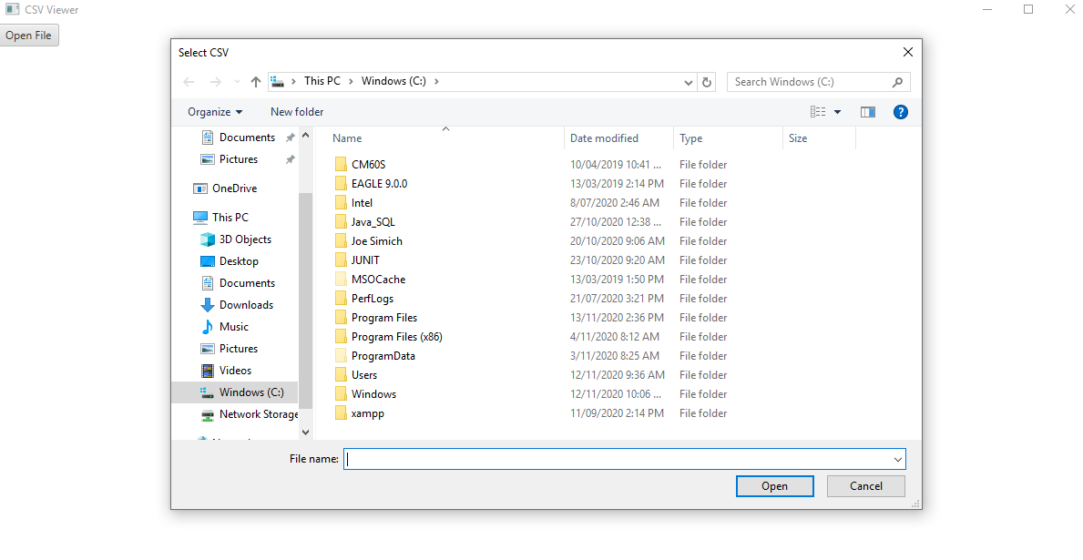

Figure 1.1



Figure 1.2

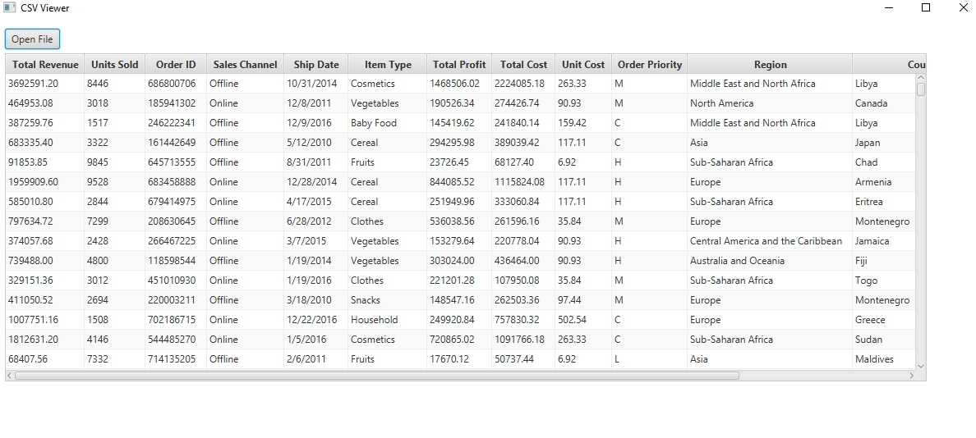

Figure 1.3

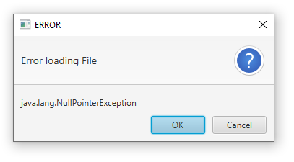

Figure 1.4

END OF TEST TABLE

## Implementation

The application has been uploaded to GitHub under the url: <https://github.com/CalvinMoylanTAFE/JavaThreePortfolio/tree/main/QuestionSix>  
Here we will be able to update the repository if any future changes are necessary such as a bug fix or a future feature. The application can be implemented on any computer that supports Java Runtime Environment so deploying the application will require JavaRE to be installed.